Hi Friends,

This document is created to help students for the second part of speaking exam i.e. 12 questions that has listening in it and answering. Since they are multiple choice questions, if you click right answers in this section the probability of clearing the exam increases. I have tried to share my knowledge around this. Just in case you have something to let me know you can whatsapp me, Harshit Doshi at +31 657096917.

**You will get 2-3 questions with answers that have same words in each multiple choices, but sequence of them is different. In such question you need to select answer that is as per current sequence grammatically. Honestly you don’t need to listen audio for such questions where multiple choices in answers have same words 😉 and save time by understanding and clicking the right answer with simple below mentioned grammar rules 😊**

**Rule 1:** Verb is at **2nd place** and at **last place** in a sentence, if sentence starts with subject(ik, wij etc). This means that if a sentence has two verbs than that **needs to be at the end** eg: gedaan, gegetan, gekocht, geparkeerd

Eg. 1 🡪 ik **ging** gisteren hardlopen **gedaan**

Eg. 2 🡪 ik **heb** met de lunch een tosti in the Kantine **gegeten**

Eg.3 🡪Ik **kan** dat niet **zien** **is correct**

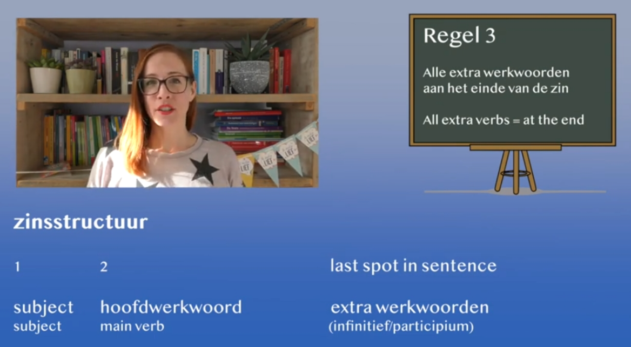

**Rule 2:**

**ONLY** if a sentence starts with When (Gisteren, Morgen), then second word is always the verb, see below snapshot example:-

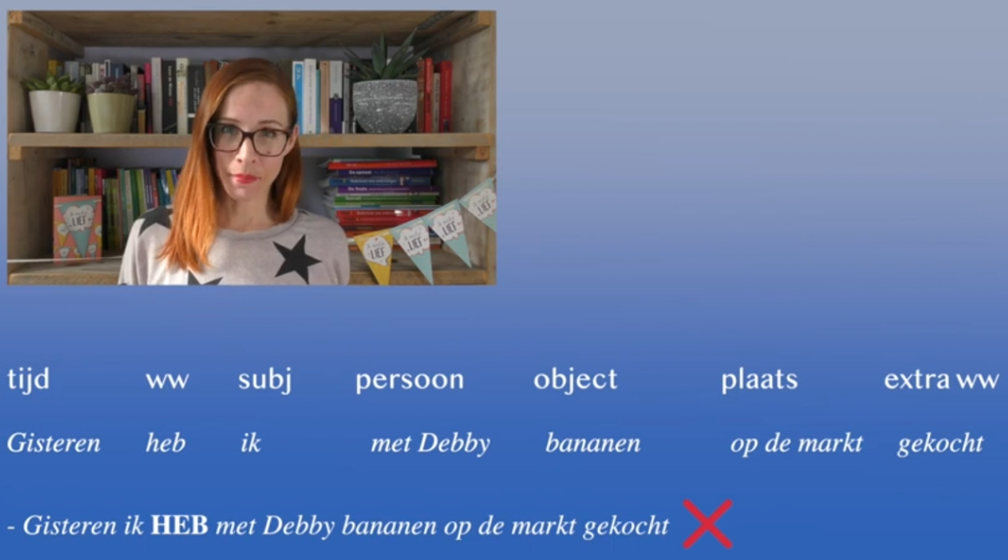

Eg 🡪 Nee, ik neem nooit de trein 🡪 **is correct**

Eg 🡪 Nooit, neem ik de trein **is correct** &

Eg 🡪 Nee, ik nooit nemen de trein **is wrong**

Eg 🡪 Nooit, ik de trein neem **is wrong**

Eg 🡪 Dan drink ik eerst koffie **is correct**

Eg 🡪 Dat ga ik doen **is wrong**

**Rule 3:** When i.e. (Time, frequency) is **always** third place **if subject(Ik) is present** eg. Gisteren, morgen,altijd, nooit. Check sentences 1 & 4 in below snapshop

Ik ging **gisteren**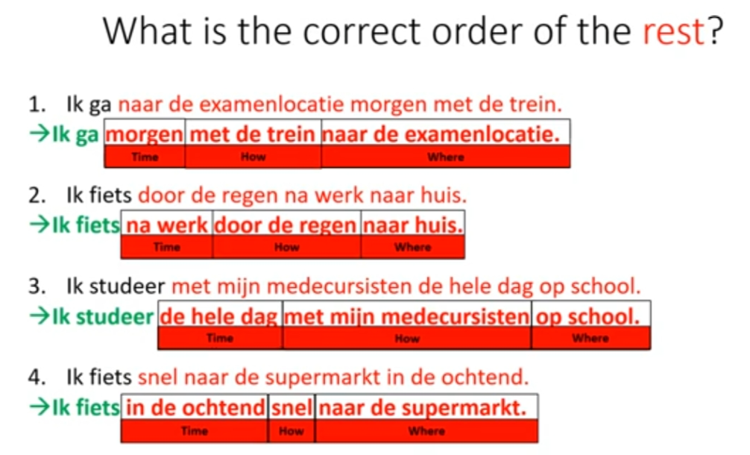

**Rule 4:** Check for Singularity & Plurality

While you listen the audio check if the reference of item or person is multiple or not. Mostly they check if you are able to use plurality correctly or not. Check below examples:-

| Singularity – one only | Plurality – more than one |
| --- | --- |
| Tas (Bag) | Tassen (Bag**s**) |
| Brood Lig**t** | Broodj**es** ligg**en** |
| Kind spel**t** | Kinder**en** spell**en** |

**Rule 5:** **Never add t** with a verb **when there is ik** in sentence, check below examples:-

Ik heb**t is** incorrect 🡪 ik heb is correct

Ik ben**t is** incorrect 🡪ik ben is correct

**Rule 5.1:** if t is added in verb then add "en" at end in verb for eg Hij zie**t** veel fietsen. T will be added only when sentence starts with hij , zij , wij i.e. anyone but not ik.

**Rule 6:** Haar(in Dutch) is Her but there is no word for him in Dutch so you need to use **zijn.** In exam they have one of the choices as Hem which is **incorrect**

**7. Common dutch phrases/word used:-** Select these in answers after listening audio and understanding the context. If possible simple byheart them

Betterschaap 🡪 Wishing someone health wishes

Veel Sterkte 🡪 same like above related to health wishes and being strong

Gefeliciteerd 🡪 wishes for birthday, exam success, anniversary, marriage etc.

Gecondoleerd 🡪 sad demise, death etc. matters

dat komt wel goed 🡪 that's fine

dat geeft niet 🡪 that does not matter

natuurlijk ga je gang 🡪 of course go ahead

dat komt wel goed 🡪 that's fine

**8. Some basic listening questions** below asked:- They just check your basic listening skills same like luisteren exam

Hoe laat 🡪 What time

Hoe oud 🡪 How old

Wanner 🡪 When

Hoe laang 🡪 How long

**9. Always Use “om” with time and “op” with day**

Eg. Ik speel op donderdag om 8 uur

***Video below helped me shape up this document, may be help you as well understand better all the grammar concepts:-***

[***https://youtu.be/OS0GQdPHrcg?si=pQr6CtJ6IfI0GfcP***](https://youtu.be/OS0GQdPHrcg?si=pQr6CtJ6IfI0GfcP)